Octagonal Antiprism
# Source: AI Source: Provided by: [Data Path: Persons Table -> ID Column: 1, Name_En Column: Motasem Essam] -> From: [ChatGPT] on [7/25/2026]
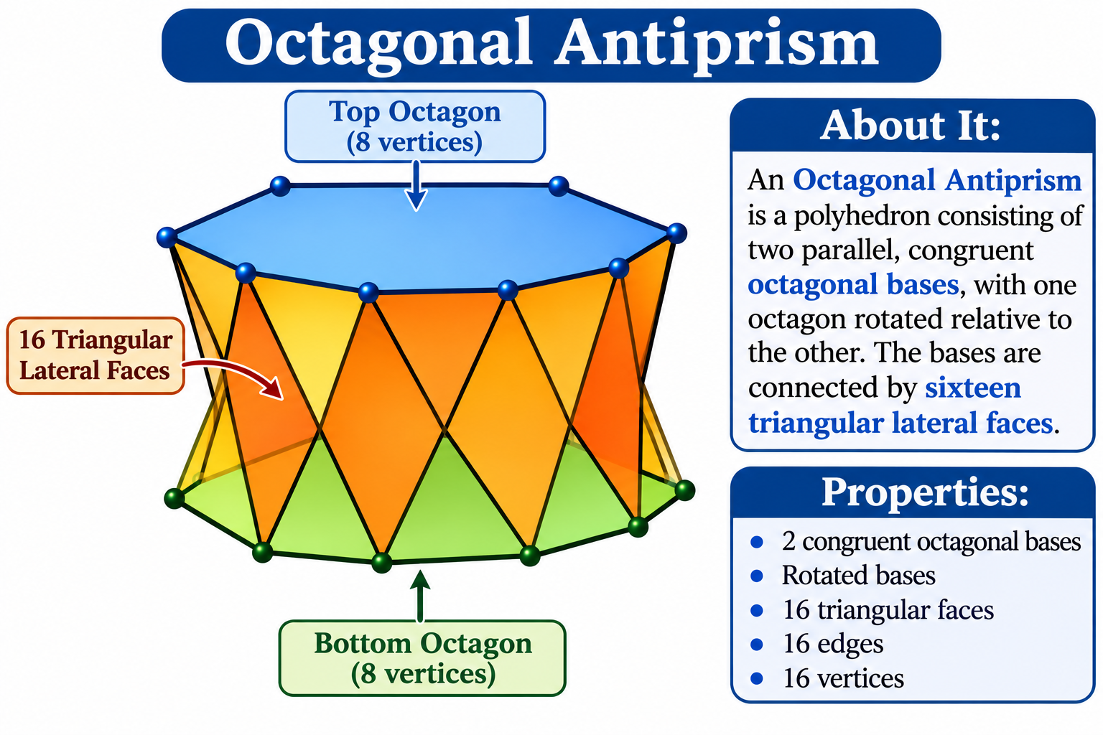

Definition
# Source: AI Source: Provided by: [Data Path: Persons Table -> ID Column: 1, Name_En Column: Motasem Essam] -> From: [ChatGPT] on [7/25/2026]
An Octagonal Antiprism is a polyhedron consisting of two parallel, congruent octagonal bases, with one octagon rotated relative to the other. The bases are connected by sixteen triangular lateral faces.
It is a type of antiprism with octagonal bases and a twisted arrangement of its lateral triangles.
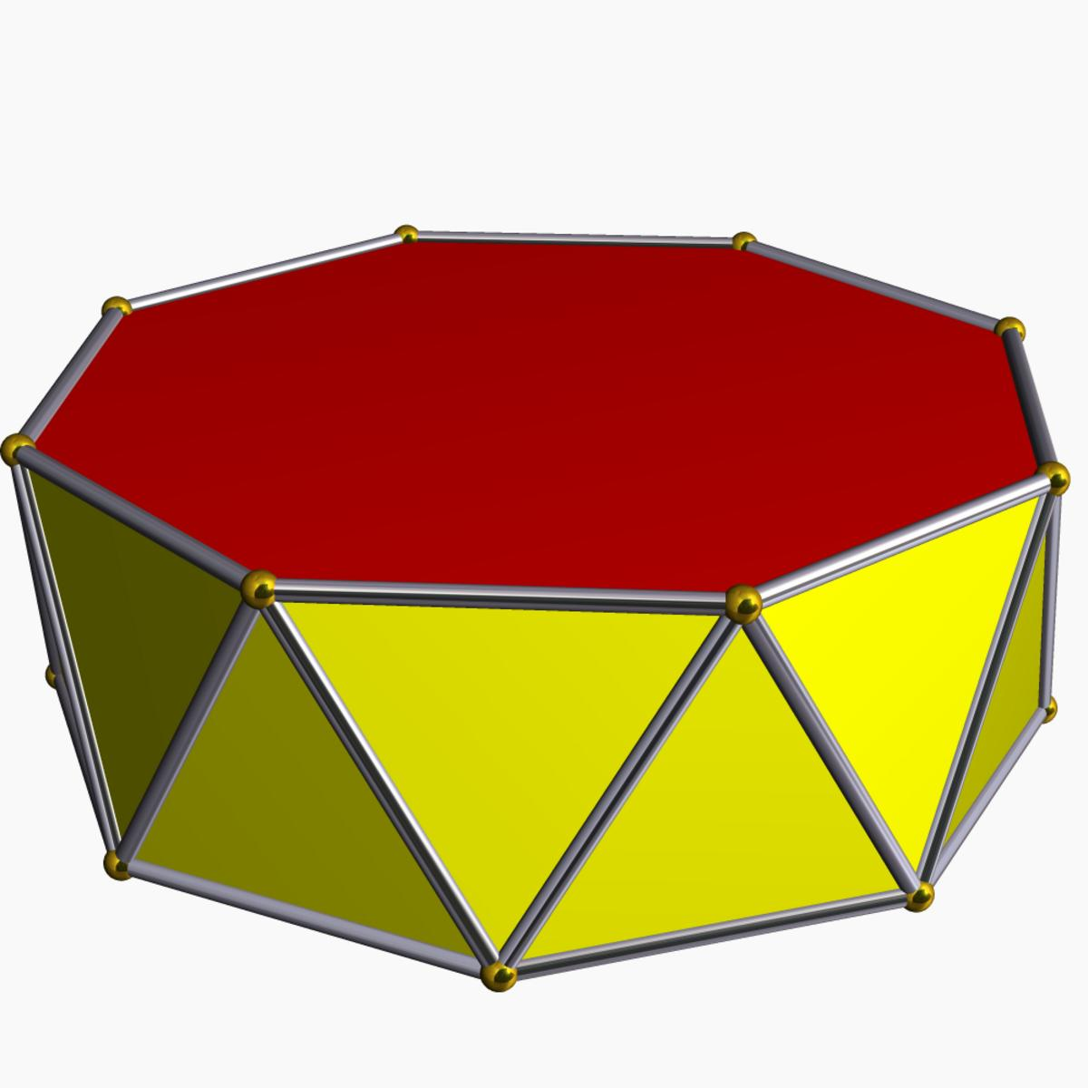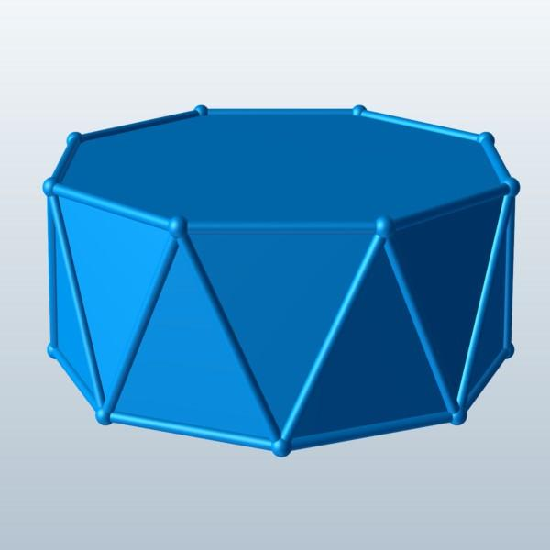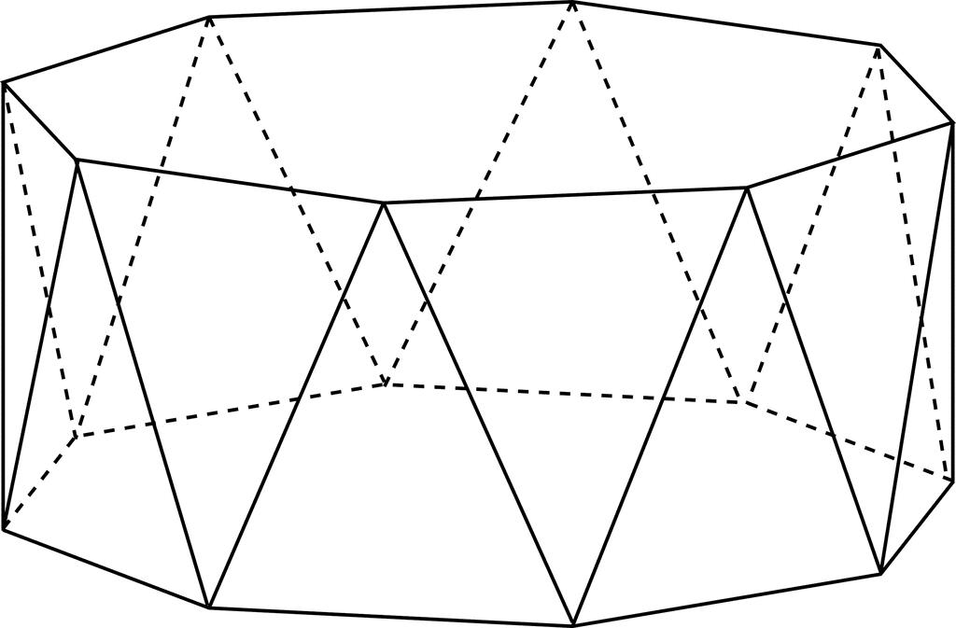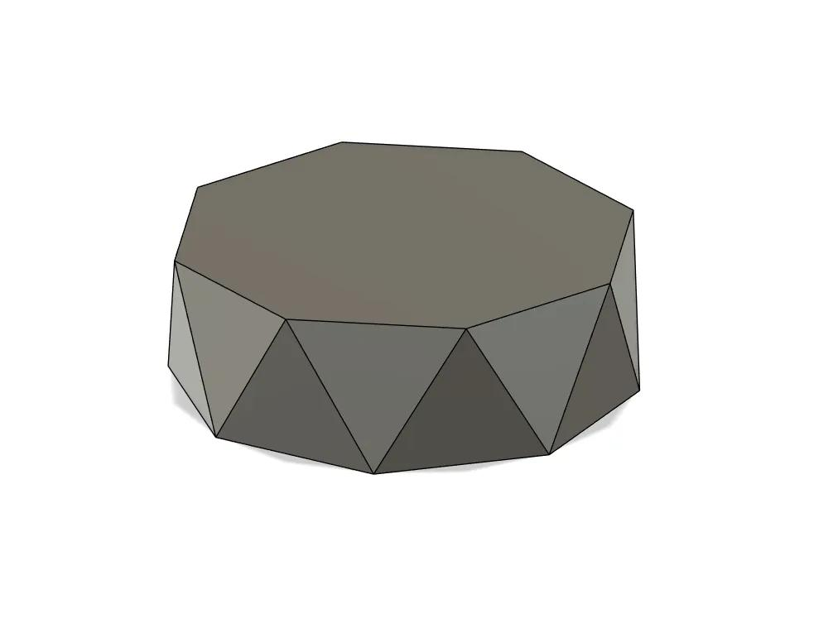

Geometric Structure
# Source: AI Source: Provided by: [Data Path: Persons Table -> ID Column: 1, Name_En Column: Motasem Essam] -> From: [ChatGPT] on [7/25/2026]
The octagonal antiprism consists of:
- Upper Octagonal Base: An octagon forming the top face.
- Lower Octagonal Base: A congruent octagon forming the bottom face, rotated relative to the upper base.
- Triangular Lateral Faces: Sixteen triangles connecting the two octagonal bases.
- Vertices: Sixteen vertices, with eight on each base.
- Edges: Thirty-two edges connecting the vertices.

Face Composition
# Source: AI Source: Provided by: [Data Path: Persons Table -> ID Column: 1, Name_En Column: Motasem Essam] -> From: [ChatGPT] on [7/25/2026]
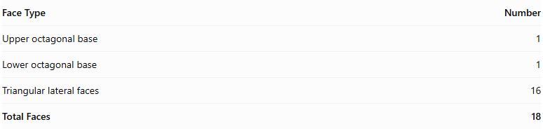
Face Type | Number
Upper octagonal base | 1
Lower octagonal base | 1
Triangular lateral faces | 16
Total Faces | 18

Mathematical Properties
# Source: AI Source: Provided by: [Data Path: Persons Table -> ID Column: 1, Name_En Column: Motasem Essam] -> From: [ChatGPT] on [7/25/2026]
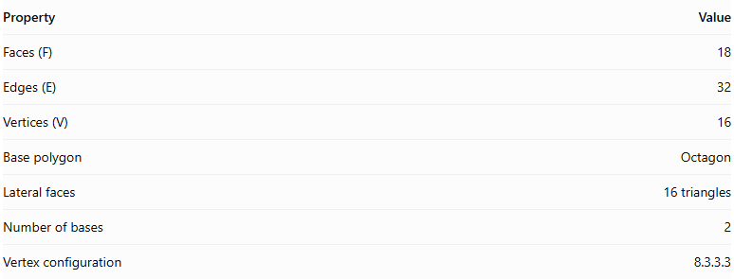
Property | Value
Faces (F) | 18
Edges (E) | 32
Vertices (V) | 16
Base polygon | Octagon
Lateral faces | 16 triangles
Number of bases | 2
Vertex configuration | 8.3.3.3
Euler's formula:
$$V-E+F=2$$
$$16-32+18=2$$
Regular Octagonal Antiprism
In a regular octagonal antiprism:
- Both octagonal bases are regular and congruent.
- The upper and lower bases are rotated relative to each other, typically by ${22.5}^{∘}$.
- The sixteen lateral triangular faces are equilateral.
- The vertices have the same local arrangement.

Constructing Octagonal Antiprism in Solid Geometry

Geometric Instruments Used
# Source: AI Source: Provided by: [Data Path: Persons Table -> ID Column: 1, Name_En Column: Motasem Essam] -> From: [ChatGPT] on [7/25/2026]
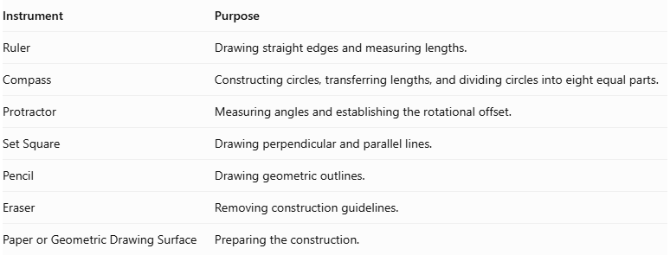
Instrument | Purpose
Ruler | Drawing straight edges and measuring lengths.
Compass | Constructing circles, transferring lengths, and dividing circles into eight equal parts.
Protractor | Measuring angles and establishing the rotational offset.
Set Square | Drawing perpendicular and parallel lines.
Pencil | Drawing geometric outlines.
Eraser | Removing construction guidelines.
Paper or Geometric Drawing Surface | Preparing the construction.

Instrument-Based Construction Procedures
# Source: AI Source: Provided by: [Data Path: Persons Table -> ID Column: 1, Name_En Column: Motasem Essam] -> From: [ChatGPT] on [7/25/2026]
The octagonal antiprism can be constructed using geometric instruments and classical geometric drawing techniques, without using coordinate-based construction.

Constructing the Lower Octagonal Base
# Source: AI Source: Provided by: [Data Path: Persons Table -> ID Column: 1, Name_En Column: Motasem Essam] -> From: [ChatGPT] on [7/25/2026]
- Draw a circle using a compass.
- Divide the circle into eight equal angular sections.
- Each central angle measures:
$$\frac{{360}^{∘}}{8}=\boxed{{45}^{∘}}$$
- Mark the eight vertices on the circumference.
- Connect consecutive vertices using a ruler to form a regular octagon.
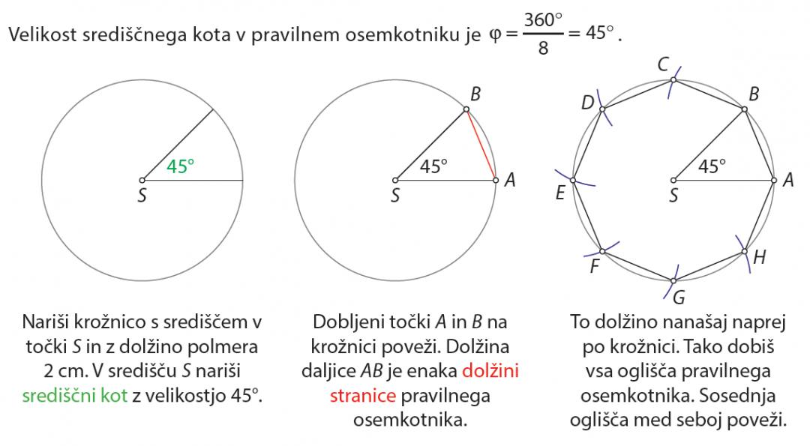

Constructing the Upper Octagonal Base
# Source: AI Source: Provided by: [Data Path: Persons Table -> ID Column: 1, Name_En Column: Motasem Essam] -> From: [ChatGPT] on [7/25/2026]
- Draw a second regular octagon congruent to the lower base.
- Position it above and parallel to the lower octagon.
- Rotate its orientation by half the central angle:
$$\frac{{45}^{∘}}{2}=\boxed{{22.5}^{∘}}$$
- Maintain the same side length and geometric proportions.
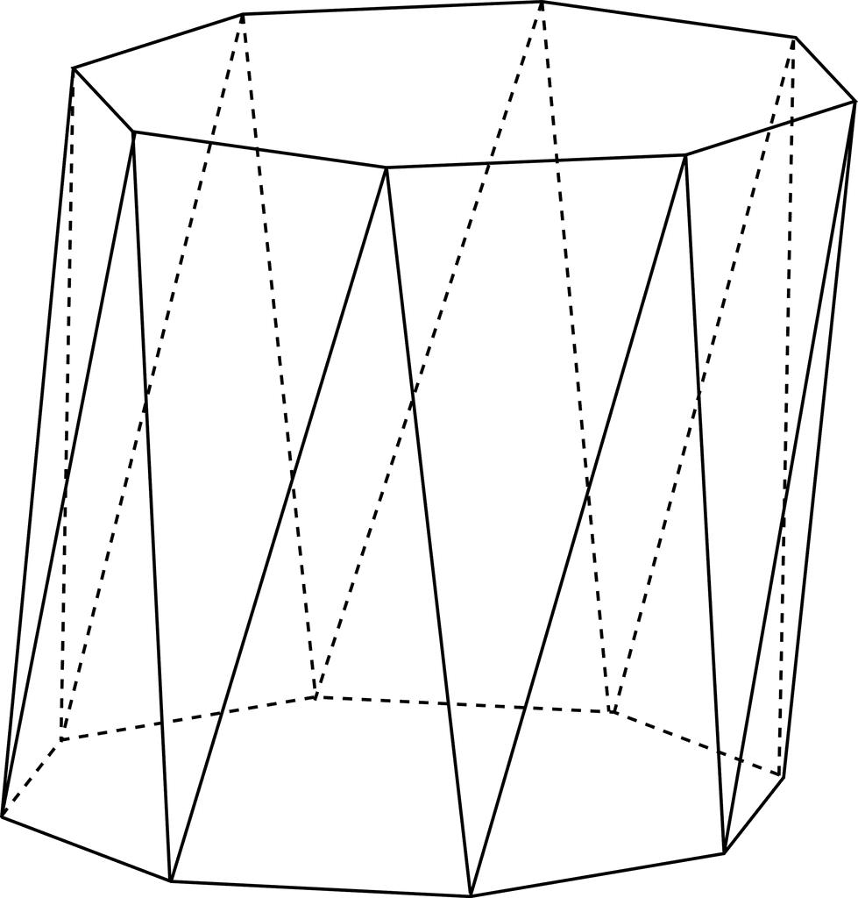

Connecting the Two Bases
# Source: AI Source: Provided by: [Data Path: Persons Table -> ID Column: 1, Name_En Column: Motasem Essam] -> From: [ChatGPT] on [7/25/2026]
- Connect each vertex of the lower octagon to the two nearest vertices of the upper octagon.
- Repeat the connections around the entire solid.
- Ensure the connecting edges alternate between the upper and lower bases.
- Form sixteen triangular lateral faces.

Completing the Solid
# Source: AI Source: Provided by: [Data Path: Persons Table -> ID Column: 1, Name_En Column: Motasem Essam] -> From: [ChatGPT] on [7/25/2026]
- Complete all sixteen triangular lateral faces.
- Emphasize the visible edges.
- Use dashed lines for hidden edges when necessary.
- Verify that both octagonal bases are congruent and parallel.
- Check that the upper base has the correct 22.5° rotational offset.

Constructing a Net
# Source: AI Source: Provided by: [Data Path: Persons Table -> ID Column: 1, Name_En Column: Motasem Essam] -> From: [ChatGPT] on [7/25/2026]
A net of an octagonal antiprism contains:
- Two congruent octagonal bases.
- Sixteen triangular lateral faces.
- A connected arrangement of faces with matching edge lengths and correct face adjacency.
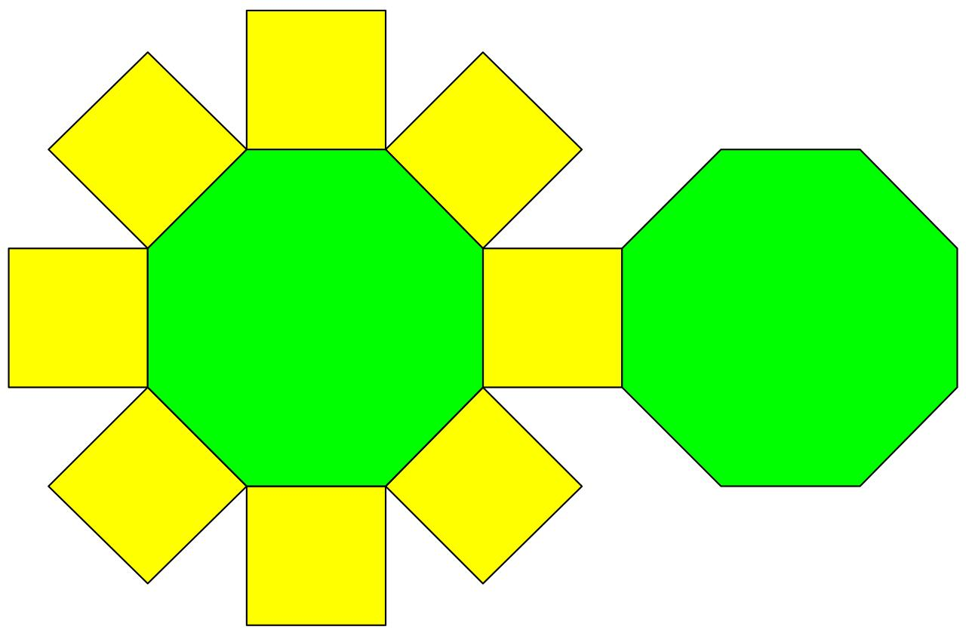

Key Points
# Source: AI Source: Provided by: [Data Path: Persons Table -> ID Column: 1, Name_En Column: Motasem Essam] -> From: [ChatGPT] on [7/25/2026]
- It has two parallel octagonal bases.
- The bases are rotated relative to each other.
- It has sixteen triangular lateral faces.
- It contains 18 faces, 32 edges, and 16 vertices.
- Its regular form is a uniform polyhedron.

Classification
# Source: AI Source: Provided by: [Data Path: Persons Table -> ID Column: 1, Name_En Column: Motasem Essam] -> From: [ChatGPT] on [7/25/2026]
Solid Geometry
└── Types of Solids
└── Antiprism
└── Types of Antiprisms
└── Octagonal Antiprism
├── Upper Octagonal Base
├── Lower Octagonal Base
└── Triangular Lateral Faces

Conclusion
# Source: AI Source: Provided by: [Data Path: Persons Table -> ID Column: 1, Name_En Column: Motasem Essam] -> From: [ChatGPT] on [7/25/2026]
An Octagonal Antiprism is an antiprism with two congruent octagonal bases and sixteen triangular lateral faces, arranged in a twisted configuration.

